Report from interview with Veterinarians without borders Canada
During the Ecohealth meeting in Montreal August 2014, I interviewed David Waltner-Toews, funder of VSF Canada, and Erin Fraser, executive director.
They told me the story about the start of the organisation. In the beginning it was mainly associated with David’s work at the university, but as it grew bigger there were more activities outside the academia as well.
The big take-off for VSF Canada was when they liaised with the airlines to get donated points that they could use for flying, and then they started to be able to do activities abroad.
The structure now is that it is no longer a membership organization, but people can donate money, and it is an independent board. They have activities in many different countries, and would be happy to collaborate with us in any way possible, but they mainly recommend VSF –Sweden to join the international and European VSF.

Johanna Lindahl for VSF Sweden.

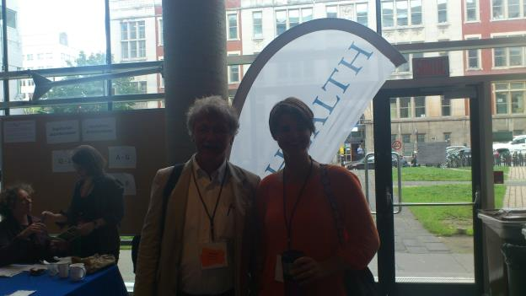

Per capsulam beslut avseende möte med VSF Canada
9 juli 2014 kom förfrågan till styrelsen om beslut om ett möte med VSF Canada.
3 svar positiva inkom under de kommande dagarna.

Johanna Lindahl

